**PROGRAM TO WRITE EXCEL SHEET USING POI**

**CODE:**

**package** july10;

**import** java.io.FileOutputStream;

**import** java.io.IOException;

**import** org.apache.poi.ss.usermodel.Cell;

**import** org.apache.poi.ss.usermodel.Row;

**import** org.apache.poi.xssf.usermodel.XSSFSheet;

**import** org.apache.poi.xssf.usermodel.XSSFWorkbook;

**public** **class** Poi {

**public** **static** **void** main(String[] args) **throws** IOException {

XSSFWorkbook workbook = **new** XSSFWorkbook();

XSSFSheet sheet = workbook.createSheet("Book2");

Object[][] bookData = {

{"NAME", "SUBJECT1", "MARK1", "SUBJECT2", "MARK2"},

{"REENA", "ENGLISH", 95,"MATHS", 100},

{"MEENA", "ENGLISH", 90,"MATHS", 98},

{"VEENA", "ENGLISH", 98,"MATHS", 100},

{"TEENA", "ENGLISH", 97,"MATHS", 99},

};

**int** rowCount = 0;

f**or** (Object[] aBook : bookData) {

Row row = sheet.createRow(rowCount++);

**int** columnCount = 0;

**for** (Object field : aBook) {

Cell cell = row.createCell(columnCount++);

**if** (field **instanceof** String) {

cell.setCellValue((String) field);

}

**else** **if** (field **instanceof** Integer)

{

cell.setCellValue((Integer) field);

}

}

}

**try** (FileOutputStream outputStream = **new** FileOutputStream("Book2.xlsx")) {

workbook.write(outputStream);

}

}

}

**OUTPUT:**

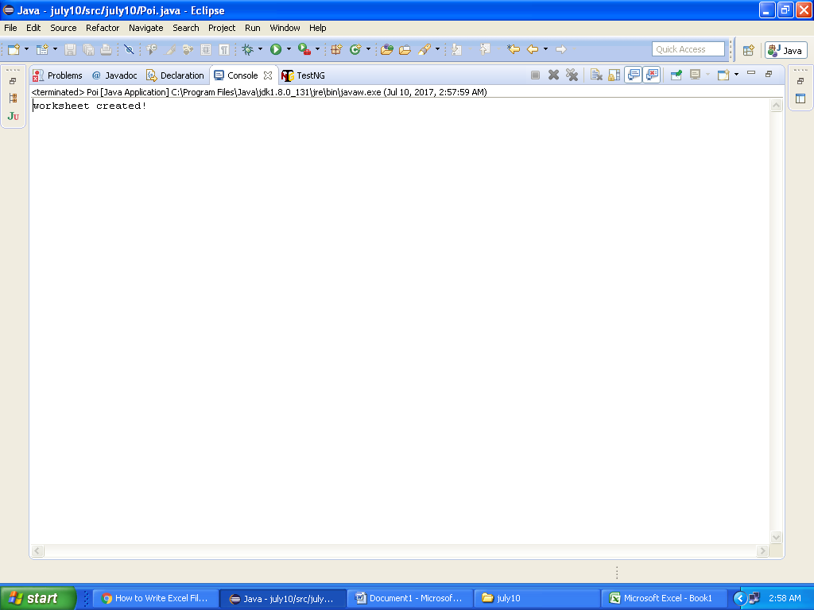

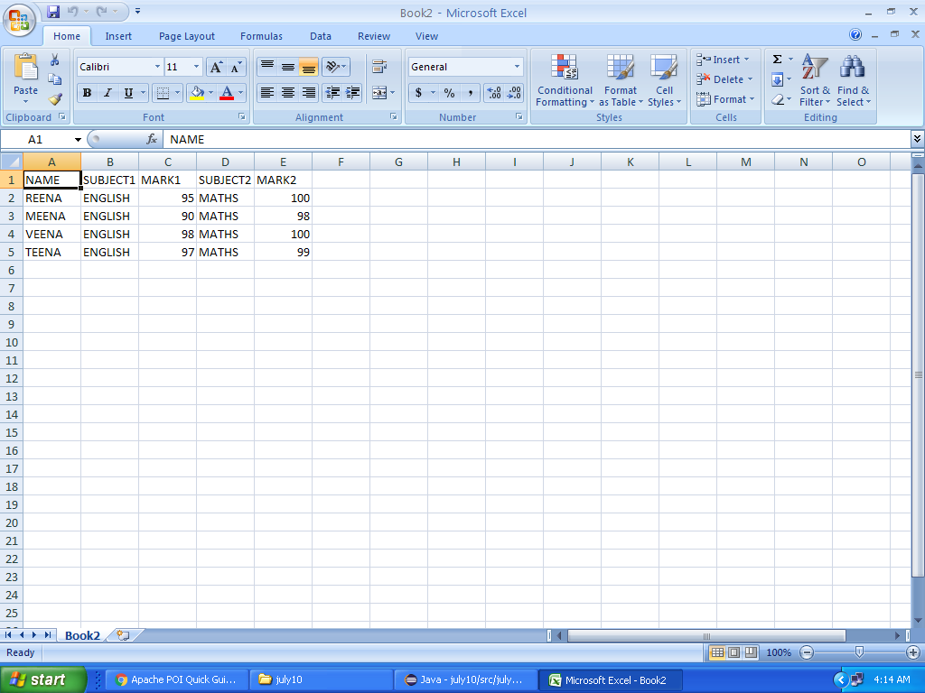

**PROGRAM TO READ EXCEL SHEET USING POI**

**CODE:**

**package** july10;

**import** java.io.File;

**import** java.io.FileInputStream;

**import** java.io.IOException;

**import** java.util.Iterator;

**import** org.apache.poi.ss.usermodel.Cell;

**import** org.apache.poi.ss.usermodel.Row;

**import** org.apache.poi.ss.usermodel.Sheet;

**import** org.apache.poi.ss.usermodel.Workbook;

**import** org.apache.poi.xssf.usermodel.XSSFWorkbook;

**public** **class** PoiRead {

**public** **static** **void** main(String[] args) **throws** IOException {

String excelFilePath = "Book2.xlsx";

FileInputStream inputStream = **new** FileInputStream(**new** File(excelFilePath));

Workbook workbook = **new** XSSFWorkbook(inputStream);

Sheet firstSheet = workbook.getSheetAt(0);

Iterator<Row> iterator = firstSheet.iterator();

**while** (iterator.hasNext()) {

Row nextRow = iterator.next();

Iterator<Cell> cellIterator = nextRow.cellIterator();

**while** (cellIterator.hasNext()) {

Cell cell = cellIterator.next();

**switch** (cell.~~getCellType~~()) {

**case** Cell.~~CELL_TYPE_STRING~~:

System.***out***.print(cell.getStringCellValue());

**break**;

**case** Cell.~~CELL_TYPE_BOOLEAN~~:

System.***out***.print(cell.getBooleanCellValue());

**break**;

**case** Cell.~~CELL_TYPE_NUMERIC~~:

System.***out***.print(cell.getNumericCellValue());

**break**;

}

System.***out***.print(" - ");

}

System.***out***.println();

}

workbook.close();

inputStream.close();

}

}

**OUTPUT:**

